Name: udaya byreddy

Student id: 16293204

Class id: 3

Lab id: 6_2

Partner name: Madhuri sarda

Below are the screen shots of code snippets of login, register, google search API and Twitter search API

1. Register method for registering a user and storing it in local storage

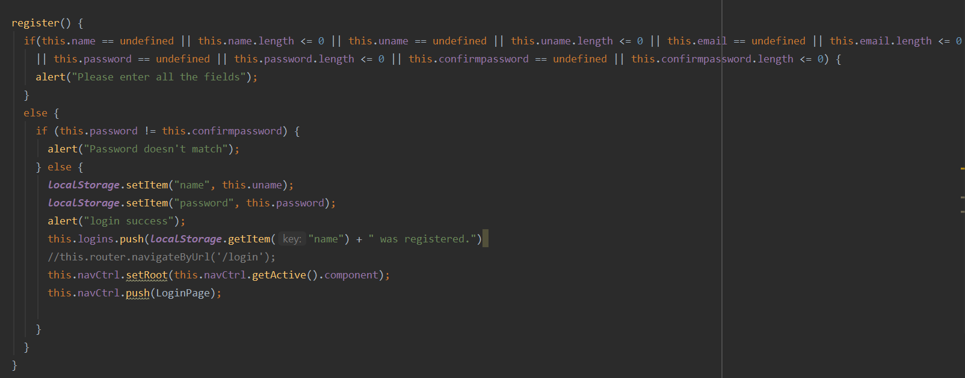

2. login method to allow login successfully and lead to google search API after successful login. Validation done from data of local storage.

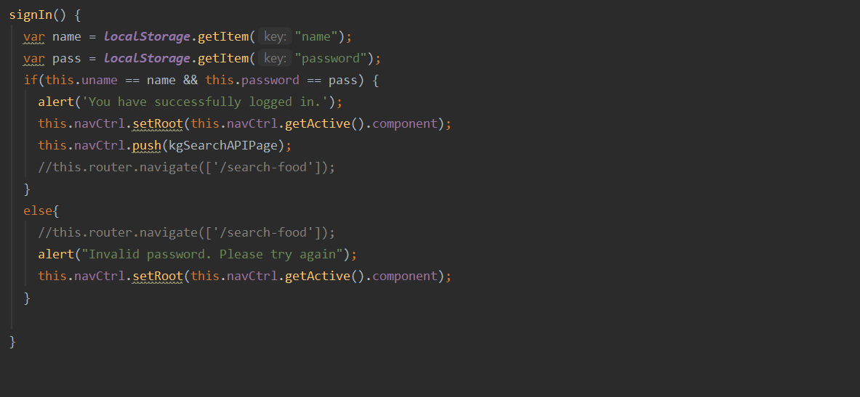

1. Below screen shot is for google search API

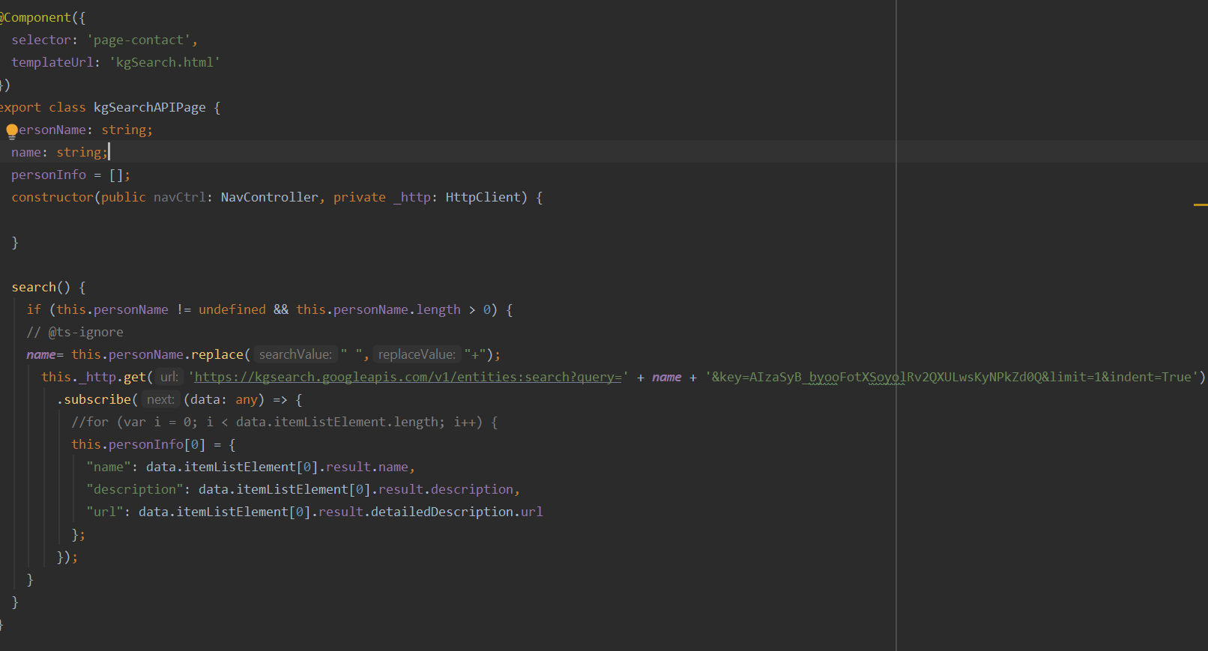

1. Below is the screen shot of twitter search API

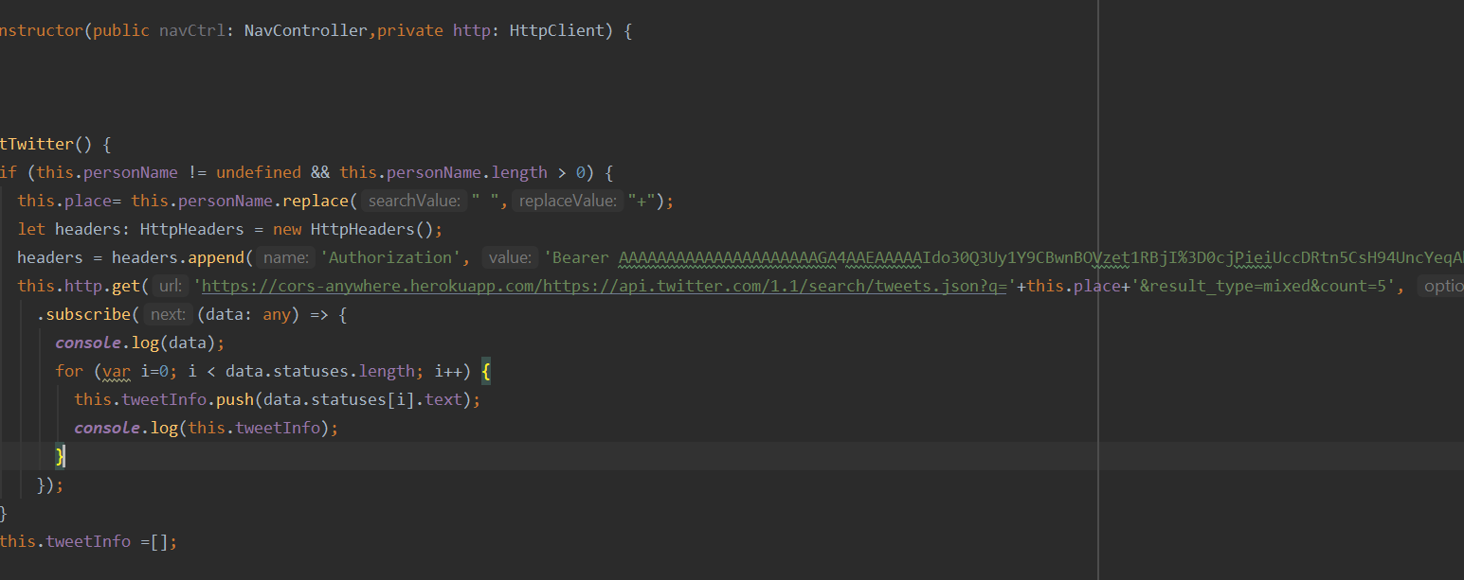

Source code for google search API:

<ion-header>

<ion-navbar>

<ion-title>

Search person/place

</ion-title>

</ion-navbar>

</ion-header>

<ion-content padding class="bg"> <ion-item>

<ion-input [(ngModel)]="personName" placeholder="Search for a person/place here" type="text"></ion-input>

</ion-item>

<button ion-button (click)="search()">Search</button>

<div class="panel-body">

<div *ngFor="let result of personInfo" class="list-group-item clearfix">

<div class="pull-left">

<h4 class="list-group-item-text">Name : {{ result.name }}</h4>

<h4 class="list-group-item-text">Description : {{ result.description }}</h4>

<h4 class="list-group-item-text">To visit the wiki page <a target="_blank" href='{{ result.url }}'>Click here</a></h4>

</div>

</div>

</div>

<ion-list>

<ion-item-sliding *ngFor="let t of todos">

<ion-item>

{{t}}

</ion-item>

<ion-item-options side="right">

<button ion-button color="danger" (click)="delete(t)">

<ion-icon name="trash"></ion-icon> Delete

</button>

</ion-item-options>

</ion-item-sliding>

</ion-list>

</ion-content>

Below code is for register API

import { Component } from '@angular/core';

import {AlertController, NavController} from 'ionic-angular';

import {LoginPage} from "../login/login";

@Component({

selector: 'page-about',

templateUrl: 'register.html'

})

export class RegisterPage {

uname: string;

password: string;

name: string;

email: string;

confirmpassword: string;bg

logins = [];

constructor(public alertCtrl: AlertController, public navCtrl: NavController) {

}

register() {

if(this.name == undefined || this.name.length <= 0 || this.uname == undefined || this.uname.length <= 0 || this.email == undefined || this.email.length <= 0

|| this.password == undefined || this.password.length <= 0 || this.confirmpassword == undefined || this.confirmpassword.length <= 0) {

alert("Please enter all the fields");

}

else {

if (this.password != this.confirmpassword) {

alert("Password doesn't match");

} else {

localStorage.setItem("name", this.uname);

localStorage.setItem("password", this.password);

alert("login success");

this.logins.push(localStorage.getItem("name") + " was registered.")

//this.router.navigateByUrl('/login');

this.navCtrl.setRoot(this.navCtrl.getActive().component);

this.navCtrl.push(LoginPage);

}

}

}

}